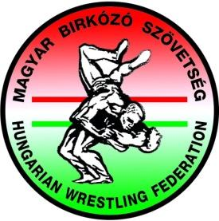 | MAGYAR BIRKÓZÓ SZÖVETSÉG  HUNGARIAN WRESTLING FEDERATION  1146 Budapest, Istvánmezei út 1-3. (MSH) I. em. 104.  Tel.: +36-1-460-6848 E-mail: birkszov@elender.hu  www.birkozoszov.hu | facebook.com/magyarbirkozosport  youtube.com/wresthun | instagram.com/wresthun
Danube Cup 2016

Organizer | Hungarian Wrestling Federation
Date of the competition | 09.07.2016. 10:00
Place | 3233 Mátraháza, Kékes-alja út 3. Mátraháza Training Camp
Weigh-in | 08.07.2016 18:00
Weight categories | KF: 42, 46, 50, 54, 58, 63, 69, 76, 85, 100 kg + 2 kg tolerance
Age group | Cadet (1999 – 2000)
Participation | 12 athletes; 1 trainer; 1 team leader; 1 referee;
Financial condition | The Hungarian Wrestling Federation will provide full accommodations and meal  from 08th of July until 12th of July 2016 afternoon of invited delegations.
Technical condition | The team competitions will be held in accordance with the UWW Regulations.
Program of the training camp | 2016.07.10 2016.07.11 2016.07.12  7:00 -8:00 breakfast 7:00 -8:00 breakfast 7:00 -8:00 breakfast  9:00 – 11:00 training 9:00 – 11:00 training 9:00 – 11:00 training  12:00 – 13:00 lunch 12:00 – 13:00 lunch 12:00 – 13:00 lunch  16:00 – 18:00 training 16:00 – 18:00 training 13:30 – end of the training camp  19:00 – 20:00 dinner 19:00 – 20:00 dinner

Contact person:
Gábor Rögler
Youth Sport Manager
+36 20 480 86 60

